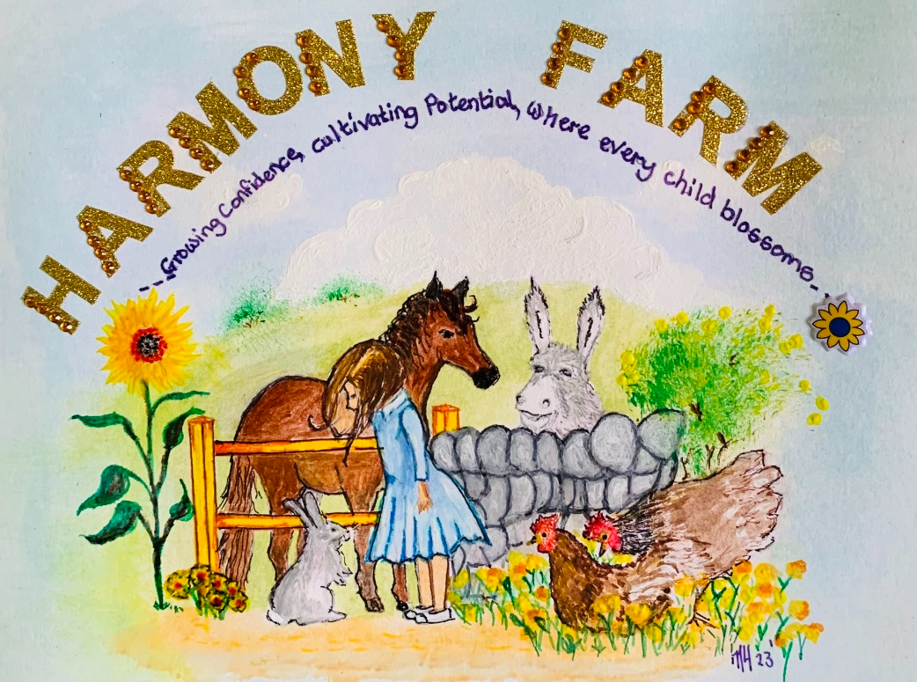

Harmony Farm Whistleblowing Policy

1. Purpose
The purpose of this whistleblowing policy is to provide a clear and confidential way for employees, volunteers, and other stakeholders to raise concerns about any unlawful or unethical practices at Harmony Farm. This policy ensures that these concerns are addressed promptly and appropriately, without fear of retaliation.

2. Scope
This policy applies to all employees, volunteers, contractors, clients, and other stakeholders of Harmony Farm . It covers any concerns related to:
• Animal welfare and treatment;
• Client safety and well-being;
• Fraud, corruption, or financial misconduct;
• Breaches of confidentiality;
• Health and safety violations;
• Discrimination, harassment, or bullying;
• Violations of farm policies and procedures;
• Any other unethical or illegal conduct;.
This policy works in tandem with our Safeguarding and Child Protection Policies.

3. Reporting Procedure
3.1. How to Report
Concerns should be reported as soon as possible to ensure timely investigation and resolution. Reports can be made through the following channels to a whistleblowing officer:
• Direct Reporting: Concerns can be raised directly with a supervisor or manager;
• Whistleblowing Hotline: 07861689002;
Email: harmonyfarm2023@gmail.com;
• Anonymous Reporting: If preferred, concerns can be reported anonymously using : written letter to-
14 Carnegie Close,
Lee on Solent
Hampshire
PO13 9JZ.

3.2. Information to Provide
When reporting a concern, please provide as much detail as possible, including:
• The nature of the concern;
• Relevant dates, times, and locations;
• Names of those involved;
• Any evidence or documentation supporting the concern.
4. Confidentiality
All reports will be treated confidentially, and the identity of the whistleblower will be protected to the fullest extent possible. Information will only be shared with individuals who need to know in order to investigate and address the concern. Every effort will be made to inform parties prior to their identity being disclosed, if necessary.
5. Protection Against Retaliation
Harmony Farm is committed to ensuring that whistleblowers are not subject to any form of retaliation, including dismissal, harassment, detriment to employment, or any adverse employment consequences. Any act of retaliation will be subject to disciplinary action, through the disciplinary policy.
Any concern covered by the Public Interest Disclosure Act 1988 raised in good faith to a Whistleblowing officer will qualify as a protected disclosure. However, any disclosure which does not meet the criteria in the act will be considered unprotected.
6. Investigation Process
Upon receiving a report, Harmony Farm will take the following steps:
1. Acknowledge receipt of the report within 24 hours;
2. Conduct a preliminary review to determine the appropriate course of action;
3. If necessary, initiate a formal investigation, which may include interviews, document reviews, and consultation with relevant experts;
4. Provide feedback to the whistleblower, if appropriate, while maintaining confidentiality.
7.1 Outcome and Follow-up
Following the investigation, appropriate actions will be taken based on the findings. This may include disciplinary actions, policy changes, or other corrective measures. The whistleblower will be informed of the outcome, to the extent possible, while respecting privacy and legal obligations.
7.2 Untrue or malicious allegations
Where it is demonstrated that a malicious or untrue allegation has been made the disciplinary policy may be applied in response.
8. Data processing under UK GDPR
Data under this policy will be:
- Processed lawfully, fairly and transparently;
- For a specified, legitimate purpose;
- Adequate, relevant and limited to what is necessary;
- Accurate and up to date;
- Kept in a form which permits identification for no longer than necessary;
- Processed to ensure appropriate data security.
9. Review of Policy
This whistleblowing policy will be reviewed annually and updated as necessary to ensure it remains effective and in line with best practices.
10. Raising your concern outside of Harmony Farm
For further information please see the UK government website: https://www.gov.uk/government/publications/blowing-the-whistle-list-of-prescribed-people-and-bodies--2
You may also with to report concerns via:
- NSPCC Whistleblowing Helpline;
- The Police;
- Local Authority Designated Officer (LADO)l
- Health and Safety Executive.
11.. Contact Information
For any questions or concerns regarding this policy, please contact:
Designated Whistleblowing Officer Samantha Hill
Phone : 07861689002
Email: harmonyfarm2023@gmail.com

