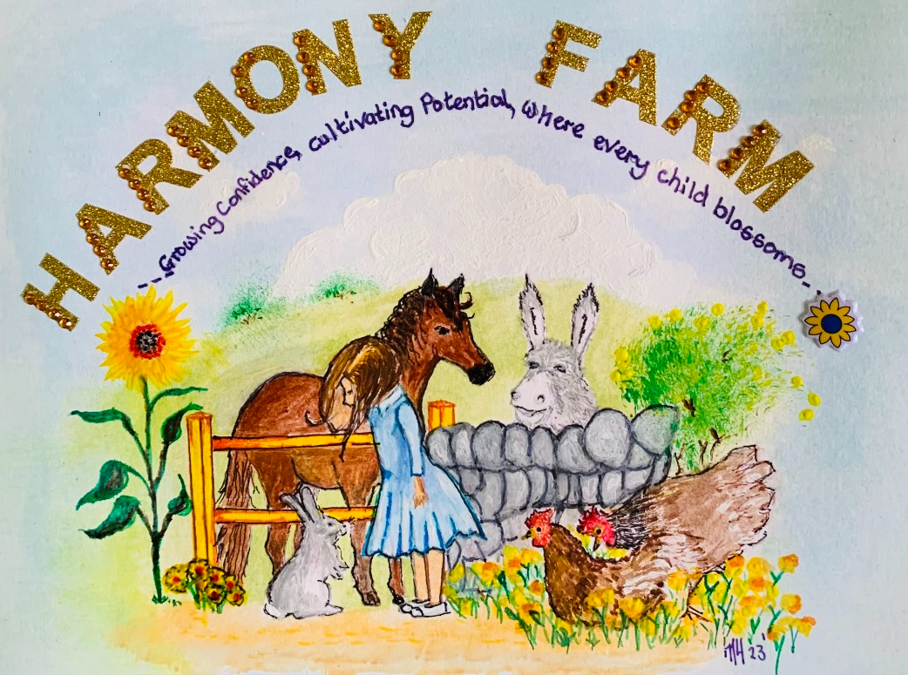

Health and Safety Policy

1. Statement of Intent
This therapy farm is committed to ensuring the health, safety, and welfare of all individuals including staff, volunteers, visitors, and service users. We provide a safe and supportive environment where animals are well cared for, and individuals can interact with them safely and meaningfully. This policy aligns with the Hampshire County Council’s Children’s Services Framework and Safeguarding Standards.

2. Responsibilities
Farm Owner / Manager will:
- - Ensure risk assessments are in place and reviewed regularly.
- - Provide appropriate training for all staff and volunteers.
- - Maintain all equipment and facilities in safe working order.
- - Ensure first aid provisions and emergency procedures are in place.
Staff and Volunteers must:
- - Follow all safety guidelines and training.
- - Report any hazards, incidents, or injuries immediately.
- - Wear appropriate clothing and protective gear.
- - Supervise service users during animal interaction activities.
Visitors / Service Users must:
- - Follow all posted signs and staff instructions.
- - Notify staff of any allergies, medical needs, or relevant concerns.

3. Risk Assessments
Risk assessments will be conducted for:
- Handling and grooming horses
- Handling and caring for small animals (e.g., rabbits, guinea pigs, goats, chickens)
- Feeding and watering procedures
- Cleaning pens, stables, and equipment
- Use of tools and grooming equipment
- Animal behavior and temperament monitoring
- Zoonotic disease control
All risk assessments are reviewed every 6–12 months or after any incident.

4. Animal Care and Welfare
- All animals are to be treated humanely and respectfully.
- Animals will be handled only by trained staff, volunteers, or supervised service users.
- Veterinary care is provided as needed, and animals are regularly checked for signs of illness or distress.
- Animal enclosures are cleaned regularly and kept in safe, hygienic condition.

5. Hygiene and Infection Control
- Handwashing stations are available and must be used before and after animal contact.
- Use of gloves and/or hand sanitizer is required in certain areas.
- Eating and drinking are restricted to designated areas away from animals.
- All minor cuts and abrasions must be covered before animal contact.
- Waste from animals is disposed of according to health regulations.

6. Manual Handling
- Staff and volunteers are trained in safe manual handling techniques.
- Heavy lifting (e.g., feed bags, hay bales) is only done with appropriate equipment or help.
- Proper posture and technique are encouraged to prevent injury.

7. Fire Safety and Emergencies
- Fire exits, extinguishers, and evacuation plans are clearly marked.
- Emergency contacts are listed and accessible to all staff.
- Regular fire drills and first aid training are conducted.
- An accident logbook is maintained.

8. Safeguarding and Supervision
- Children and vulnerable adults must be supervised at all times.
- Safeguarding policies are followed for all service users.
- DBS (Disclosure and Barring Service) checks are conducted on all staff and volunteers working with vulnerable individuals.
- Hampshire Safeguarding Children Partnership (HSCP) standards are adhered to in all safeguarding practices.

9. Training and Communication
- All staff and volunteers undergo induction training covering health and safety procedures.
- Regular refresher training sessions are conducted.
- Policies are made accessible and reviewed with staff annually or when updated.

10. Review and Monitoring
This policy will be reviewed annually or as necessary following incidents or changes in regulations. Feedback is encouraged from all stakeholders to improve safety practices.
Signed: S Hill
Name: Samantha Hill
Position: Owner
Date: 11/9/2025
Review: 11/9/2025

