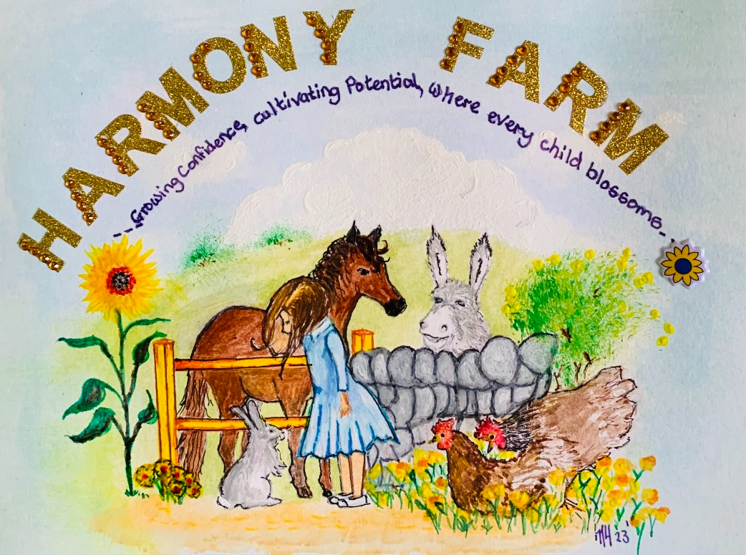

GDPR Policy

1. Purpose
This policy outlines how Harmony Farm collects, uses, stores, and protects personal data in compliance with the UK General Data Protection Regulation (GDPR) and the Data Protection Act 2018.

2. Scope
This policy applies to:
- Staff (permanent and temporary)
- Volunteers
- Service users (including children and vulnerable adults)
- Visitors
- Third-party contractors

3. Principles
Harmony Farm processes personal data lawfully, fairly, and transparently. We adhere to the following GDPR principles:
1. Lawfulness, Fairness, and Transparency
2. Purpose Limitation
3. Data Minimisation
4. Accuracy
5. Storage Limitation
6. Integrity and Confidentiality
7. Accountability

4. Legal Bases for Processing
We collect and process data on the following lawful bases:
- Consent (explicit consent is obtained for therapy sessions and marketing)
- Contract (to deliver agreed services)
- Legal Obligation (e.g., safeguarding and health and safety requirements)
- Vital Interests (in emergencies)
- Legitimate Interests (for efficient farm operations)

5. Data Collection and Use
We may collect the following types of personal data:
- Names, contact details, emergency contacts
- Medical information relevant to care or safety
- Photos/videos (with consent)
- DBS details (for staff/volunteers)
- Notes on animal-assisted therapy participation
Data is used for:
- Managing sessions and farm activities
- Health and safety monitoring
- Legal compliance (e.g., safeguarding)
- Communication with families or guardians
- We may also collect the details of any organisation whom is referring or supporting the young person.

6. Data Sharing
We only share data when:
- Required by law (e.g., safeguarding)
- Necessary with healthcare professionals or authorities including referrals and supporting organisations
- Consent is explicitly given and has not lapsed of been revoked
We never sell or share data with third parties for marketing purposes.

7. Data Storage and Security
- Personal data is stored securely (2 factor authentication, password-protected systems, locked filing cabinets in a secure location).
- Access is restricted to trained staff with a need to know.
- All data is retained only as long as necessary and securely disposed of when no longer needed in accordance with UK GDPR guidance. Details of this are available upon request.

8. Data Subject Rights
Individuals have the right to:
- Access their data
- Rectify inaccuracies
- Request erasure ("right to be forgotten")
- Restrict or object to processing
- Data portability
- Withdraw consent at any time (where applicable)
Requests can be submitted in writing to the named DPO for Harmony Farm. Please see contact details at the top of the page.

9. Consent Management
- Parental/guardian consent is required for children and vulnerable adults.
- Explicit written consent is obtained for photos, notes, and sensitive data.
- Consent can be withdrawn at any time.

10. Breach Management
In case of a data breach:
- The DPO will assess the severity and report to the Information Commissioner’s Office (ICO) within 72 hours if required: https://ico.org.uk
- Affected individuals will be advised of their rights and steps which should be taken to secure their data.
- We will work with the ICO and other partners as part of best practice to safeguard and retrieve data.

11. Roles and Responsibilities
Farm Owner / Manager:
- Acts as the Data Protection Officer
- Ensures policy compliance and training of staff
- Manages data subject requests
All Staff and Volunteers:
- Must follow UK GDPR training and data handling guidelines
- Report breaches or concerns immediately
- Act on instructions and advice received.

12. Policy Review
This policy will be reviewed annually and/or in response to changes in regulations or farm operations.
Signed: S Hill
Name: Samantha Hill
Position: Owner
Date: 11/9/2025

